 | - Far north Queensland

Reset and Recover
QSEC and their Regional Activator Crystal Williams mapped the social enterprise ecosystem in Far North Queensland. 14 social enterprises were surveyed and the results from the data informed the design of meaningful workshops. These workshops were delivered over two days, 23rd and 24th September 2020. | Key highlights  114 stakeholders and social enterprise identified within the FNQ ecosystem mapping exercise  15 Social enterprises engaged face-2-face  7 Folders as a digital tool kit  2 Surveys conducted  2 Days of workshops

Regional mapping survey  There are were 114 stakeholders and social enterprises identified in Far North Queensland. Many of those were within the social services and arts and cultural sectors. Out of those 114, 14 social enterprises responded to the survey.  The cohort of 14 social enterprise revealed 86% are running as a social enterprise (N=12) and 14% support the social enterprise ecosystem (N=2).  Types of Social Enterprise  50% Jobs focus (N=7), 29% Social Impact Delivery (N=4), 7% Service provision (N=1), 7% Economic recovery (N=1) | Maturity of the Social Enterprise  Early stage planning (N=3), Operating for up to 5 years (N=4), Operating more than 10 years (N=3), Operating up to 10 years (N=2), Startups (N=2).
New market opportunities and social accounting are high priorities for skills development!

Learning Priorities
Over 64% were looking to learn more about new opportunities!

Current Operating Capacity
Over half were 50% Open, but at low capacity!

50% Open, but at low capacity (N=7), 21% Open and fully functioning (N=3), 14 % Resetting (N=2), 14% Shut down temporarily, Open and fully functioning (N=2).

Workshop Program

DAY ONE: OFFICIAL PROGRAM
Reset and Recover Session Plan – 23th November 2020
VENUE: JCU Ideas Labs
What to bring: For best experience, feel free to bring a laptop for note taking. Please be aware that these sessions may be recorded for future use and digital distribution. Photos will also be taken at the event. Let us know if you are not comfortable with being included in photography. Free WIFI available, signage in room with passwords.
COVID 19: Your health and safety matters. Please stay at home if you have been feeling unwell or have shown any symptoms of COVID in the past 24 hours, or been in contact with anyone who has had COVID 19 in the past 14 days. Food will be served individually. Please make sure you sign in on the sheet provided.
Parking: Park in P1 – Free parking in blue marked bays only. Your Building is D4 Ideas Lab (Map below program)
Crystal Williams 0427 769 815
Time | Session Title | Host/ Speaker | Details
8:30 | Check in coffee and tea!  Room: Atrium (foyer on ground floor) | Elise/Crystal to organize sign in. | Guests to sign in at the left side of the food and beverage station.
9:00am | Welcome to Country  Room: Atrium | Bernard Singleton (Snr) | Bernard is a First Australian from Cape York Peninsula Umpila, Djabuguy, Yirrganydji. Bernard will welcome us to Country.
9:15 | Hindsight 2020 – Introduction  Room: Atrium | Dr. Narayan Gopalkrishnan | Dr. Narayan Gopalkrishnan, Chair of the Social Enterprise Network for the Tropics, SENT will open the session  https://research.jcu.edu.au/portfolio/narayan.gopalkrishnan/
9:30 | Morning Sessions  Room: Ideate | Dr. Crystal Williams | Housing keeping, Introduction.  Dr. Williams is the Deputy Chair of the Social Enterprise Network for the Tropics (SENT) and QSEC’s FNQ Regional Activator. Currently, facilitating and strengthening the growth of profit-for-purpose businesses with a particular focus on the tropics. www.linkedin.com/in/crystalwilliamsphd
9:40 | Business Model Canvas Session | Andrew Hamilton – Social Scaffolding  Elise Parups - Queensland Social Enterprise Council | What changes to your business strategy have you identified?  This session is run by Andrew Hamilton, who works with NFP’s to increase their capacity and impact, whilst supporting Corporates to create positive partnerships and long term societal change. https://www.socialscaffolding.com.au/  Elise Parups is Executive Officer at Queensland Social Enterprise Council. Consulting to business and NFPs after years of leading teams and passionately serving in the arts, education and community sectors in corporate, NFP, state and local government positions.  https://www.qsec.org.au/  (Dr. Crystal Williams, and Elise Parups in room for support)
10:30 | Morning Tea Break – (Atrium)  Light snacks and beverages served on the ground floor of the Atrium
11:00 | Mid-Session  Room: Ideate  10 minute - Reflections  Impact Measurement | With Elise and Crystal  With Andrew Hamilton  11:30 am Zoom to Nina from Social Traders | 15 min round the room discussion: what changes have you made to your business strategy?  Andrew to go through the ins and outs of impact measurement.
12:30 – 1:30 | LUNCH  Lunch and beverages served on the ground floor of the Atrium
1:30 -3:30 | Afternoon Session  Social Accounting and Reporting impact  Room: Ideate Room | With Andrew Hamilton  2:00pm Zoom to Paul McGuiness ADBT
3:30 – 4:30 | Canapés and drinks networking  Beverages and Canapé’s served on the ground floor in the Atrium  Dr. Crystal Williams - to thank everyone for attending and inform the next day session will be held at the Cairns Institute

Day TWO Tuesday 24th at the Cairns Institute D3
Time | Session Title | Host/ Speaker | Details
8:30am | Check in (Foyer) Coffee and Tea | Dr. Crystal Williams and Elise Parups (Event Hosts) | Event hosts will make everyone sign in and ask if people have been feeling unwell before coming in. Tick and sign sheet.
9:00 am | Welcome to Cairns Institute  Director, Prof. Stewart Lockie | Distinguished Professor Stewart Lockie - Director of Cairns Institute | Welcome to Cairns Institute and acknowledgement to Country.  Distinguished Professor Stewart Lockie began his research career investigating the evolution and impacts of environmental policy in agriculture. This has since been extended to studies of biodiversity conservation, environmental standards, markets in ecosystem services, food security, coastal management, resource development, management of natural and industrial hazards etc.  https://www.cairnsinstitute.jcu.edu.au/professor-stewart-lockie/
9:15 am | Selling Business to Government  Room: D3:063 | Alex Hooke Social Traders  10:15 -10:30 Zoom to Amanda Handcock FNQROC TBC - Gain some insight into the tender process in the local areas. | Alex is building the social procurement marketplace across Queensland, based in the Brisbane office. Working across both sides of the market, Alex is directly engaged with social enterprises from the certification process to growth and procurement opportunities as well as delivering value to corporate and government members through a range of services including; strategy workshops, opportunity identification, staff training and communications, systems design.  https://www.socialtraders.com.au/team/alex-hooke/
11:00 am | Morning Tea – Foyer Area  Light Snacks and Beverages served on the Ground Floor Foyer area
11:30 | Capitalising on New opportunities – Discussion group  Room: D3:063 | DR. Williams and Prof. Hurriyet Babacan  Steve Williams is to zoom in just to sit in on the event. | Discussions on the findings in the local area.  What are the issues, enablers, challenges, synergies…supports  Prof. Hurriyet Babacan - Professorial Research Fellow, Rural Economies Centre of Excellence, Regional, Economic and Policy Development. https://www.cairnsinstitute.jcu.edu.au/researchers/hurriyet-babacan/
12:00 | Mapping session with Elise Parups  D3:063 (Max 20) | Elise Parups
12:30 | LUNCH  Food and Beverages served on the Ground Floor Foyer area
1:30 | Finance and Funding  D3:063 | Andrew Hamilton  (Elise for support)
3:30 – 4:30 | Networking with the Buyers and Procurement officers  Drinks and Canapé’s  Cairns Institute Foyer  Elise Parups  Closing speech and what to expect next year!

The Buyers Session only – Run on Day TWO
Cairns Institute
1:15pm | Check In  Foyer area D3 | Dr. Crystal Williams | Sign in and guests on Covid questions
1:30 pm | How can we better our social procurement  Room: D3.059 | Alex Hooke from Social Traders | Alex is building the social procurement marketplace across Queensland, based in the Brisbane office. Working across both sides of the market, Alex is directly engaged with social enterprises from the certification process to growth and procurement opportunities as well as delivering value to corporate and government members through a range of services including; strategy workshops, opportunity identification, staff training and communications, systems design.  https://www.socialtraders.com.au/team/alex-hooke/
3:30 – 4:30 pm | Networking with Social enterprises  Canapés and beverages served in Cairns Institute Foyer  Elise Parups  Closing speech and what to expect next year!  (Caterer - The Food Factory)
Takeaways from the opportunity mapping session

FNQ opportunities and trends include but are not limited to:  - Local knowledge for consultancy  - Students and youth in regenerative agriculture  - Vaccines (Bio-medical)  - Training to set up micro businesses that deal with local issues  - Protein (insects) as new product  - Water based plans  - Skin time/screen time (Youth training on interpersonal skills)  - Waste minimization and processing  - Agricultural by-products  - Alt Energy products  - Value-added food production  - Eco-tourism  - Biofuels  - Indigifoods  - Native plants  - “Tidy” the house B4 we open to business  - Cultural knowledge: respect  - Inclusive tourism  - Mental Health & Social inclusion  - Boutique tourism (local markets)  Feedback from the surveys show the workshops where useful to Far North Queensland social enterprises!  Out of the 15 participants attending the workshops, 7 responded to the feedback survey. Here are the results: | - Livestreaming opportunities (promotion and potential for subscription)  - FNQ  - Food and coffee HOME delivery (chronic care: diabetes, the aged, cancer patients etc)  - Shebah type services  - NDIS opportunities: housekeeping, cleaning, landscape, support services  - Housing and accommodation  - Clothing products and online business  - Supply chain distribution  - Arts and cultural small business  - Film industry  - Circular economies  - Fabric industry (printing, design and manufacturing)  - Creative industries and digital services  - In-person connectivity: social isolation  - Micro businesses  - Volunteering and pro bono work  - Positive Youth ecology: skills exchange, training, supporting and running businesses  - Micro production: engineering, alcohol, readymade foods, (reducing reliance on export supply chain

How well did the RESET themes respond to FNQ’s se business needs?
29%
43%
43%

(7 respondents answered giving a level between 1-5, 1 star meaning ‘not at all’, and 5 stars indicating ‘very well’)
How well did the Reset course tools suit the needs of FNQ’s se business needs?
14%
28%
28%
28%
(7 respondents answered giving a level between 1-5, 1 star indicating ‘not at all’, and 5 stars indicating ‘very well’)
Looking forward: 2021 (from the feedback survey)
Major themes were found in the feedback, a permanent FNQ activator and ongoing grassroots workshops were high on the list for 2021!

“Funds to strengthen the local networks, specifically to build capacity and capability to support research and development, plus support local SE's to deliver effective and impactful pitches to the market!! (Quote from Participant in the workshop)

- 100% want to attend the RECOVERY program in early 2021 (N=7)
- 86% are interested in using the digital toolkit and audio recording (N=6)
Major themes for 2021 are:
- Employ a full-time coordinator/activator in FNQ (N=6)
- Tailored support/ education for grassroots level (N=3)
- Involvement from, Universities, Local and State Government and Business Communities (N=3)
- More workshops, less consultation (N=2)
- Ongoing advocacy (N=1)
- Mentoring support, particularly for First Nations peoples (N=1)

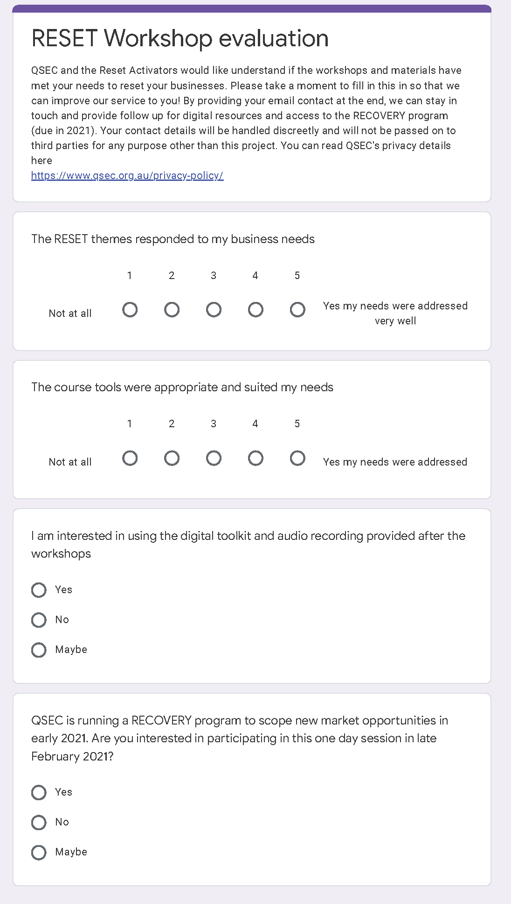
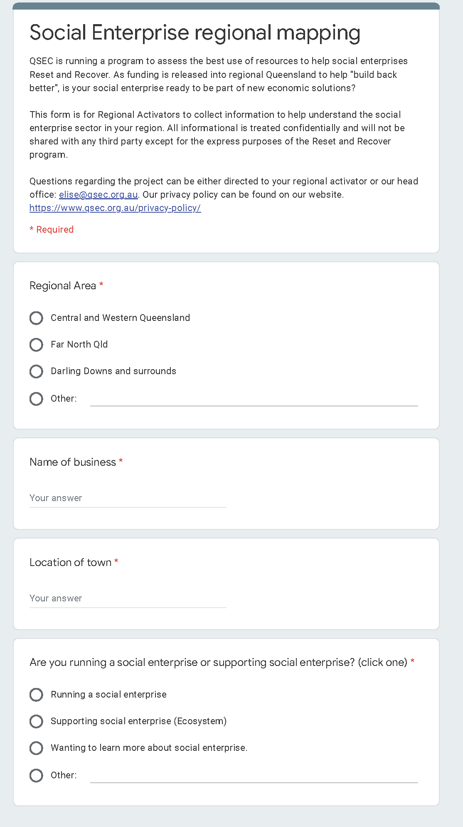
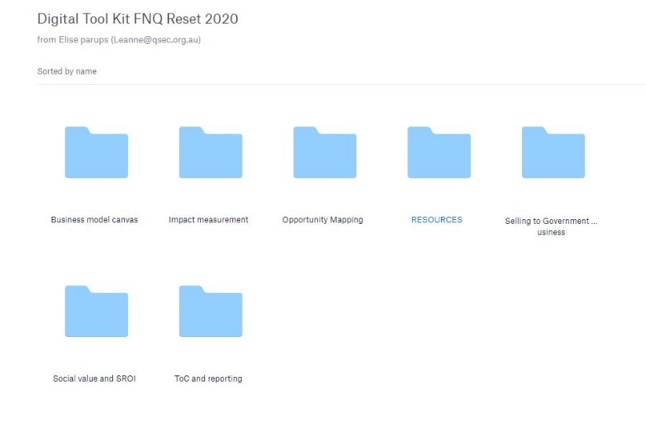
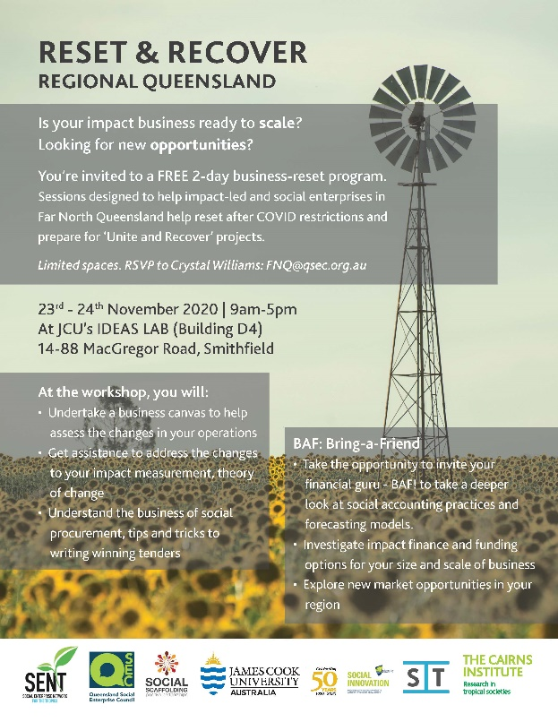
Assets
Evaluation Survey
Mapping Survey
Marketing
Digital Tool Kit

